Tips for Working with MS Excel Worksheets
Modifying Worksheets
The Fiscal Note Worksheets are currently protected. In order to modify any locked cells on a worksheet, you must first "unprotect" it. This can be accomplished from the main menu: Tools, Protection, Unprotect worksheet... After you complete any modifications, you should re-protect the worksheet from the same menu: Tools, Protection, Protect worksheet... Our worksheets are not password protected –just leave the password box empty and click ok.

Working with Text Boxes on the "Overview -- Questions" Worksheet
If you wish, use the FNOverview.doc form created in Word to answer these questions.
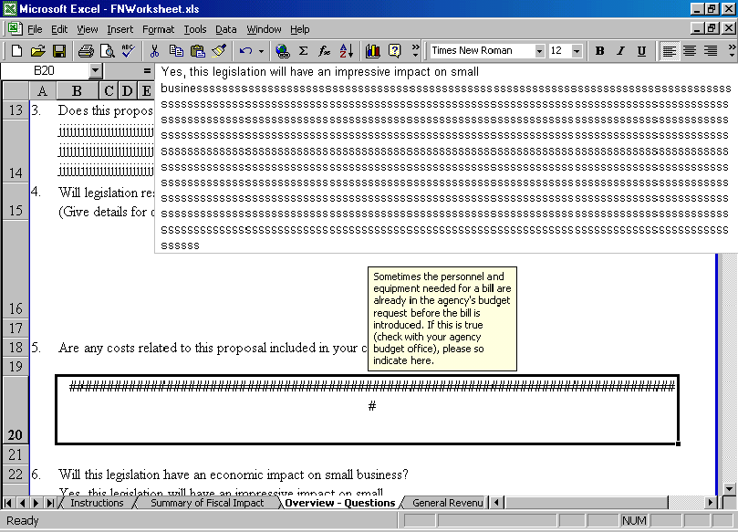A number of users have asked what to do if they need more space to answer questions on this worksheet. Unfortunately, Excel is not the easiest program to work with when it comes to formatting text! Here are a few tricks we hope will make it easier:

In the example above, too much information has been typed into the text box supplied for answering question number 5. Although the information shows up in the formula bar section of excel, the text box on the worksheet incorrectly displays a line of pound signs. ####################################################################
#
To fix this problem, unprotect the worksheet following the instructions in the first tip. Place your cursor on the line between cells 20 and 21 in the gray section to the far right of the worksheet. Drag the line under the 20 downward to increase the size of the text box appropriately. If your text still does not display properly, check the formatting of the text box.
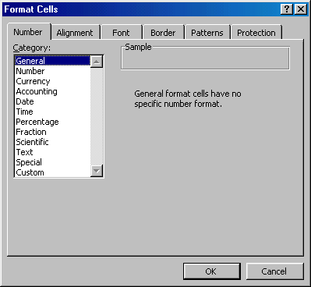

Right-click anywhere in the cell and select Format Cells…from the pop-up menu. (see example at left). From the “Number” tab, make sure General is selected in the Category: list box. Often this is enough to fix the display problem.

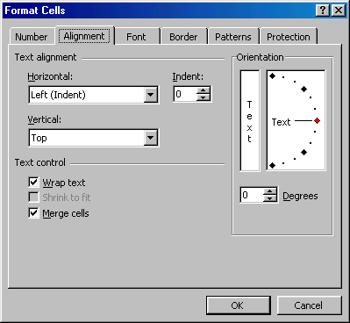
If your text still doesn’t display properly, check the settings on the “Alignment” tab. They should be set as follows:

Text alignment _________________

Horizontal: Left (Indent)
Vertical: Top

Text Control ___________________

Both Wrap Text and Merge Cells should be checked.

More Text Formatting Tips

Alt + Enter Starts a new line in a merged text cell

Special text formatting like Bold, Italics, and Underline is only available if you “unprotect” the worksheet. Tools, Protection, Unprotect Sheet… These worksheets are not password protected. Please don’t set a password when you re-protect the sheet. (see 1st page of tipsheet)
Question: “What should I do if I create a State Fund I don’t need or accidentally add a State Fund before I create all of my Federal Funds?”
Answer: The easiest way to fix this problem may be to simply close the workbook without saving changes and start over. If you have already entered a lot of data, however, you may want to manually remove the offending Funds. To accomplish this task, click on the fund’s worksheet tab and choose Edit, Delete Sheet from the main menu. Click on the “Summary of Fiscal Impact” worksheet tab. Unprotect the worksheet following the instructions at the beginning of this tip sheet. Highlight cell 17 by clicking in the gray area to the left of the worksheet. (see highlighted example below) Right-click in this area and select Delete from the pop-up menu. This will delete the entire row. (careful—make sure you are deleting the correct row or you will have to start over!) Repeat this process for every unwanted fund. Don’t forget to re-protect the worksheet after you have finished deleting rows.
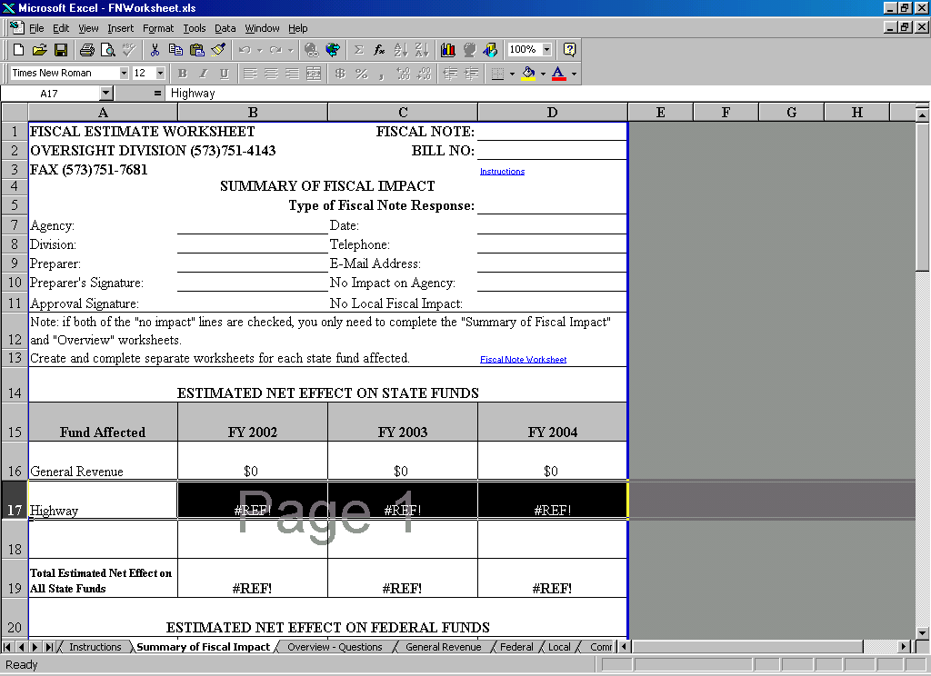

Frequently-Asked Questions

Question: “I find the pop-up help very annoying, is there any way to disable this feature?”
Answer: The pop-up help was created using the data validation feature in Excel. To “turn off” this feature, you would have to individually remove data validation from every cell in the worksheet. (Data, Validation…Settings tab, “clear all”) A better solution is to simply “drag & drop” the pop-up box out of your working area and into the gray area at the far right of the worksheet. Note: if the Microsoft help assistant is turned on (that annoying little paper-clip, puppy, wizard…), the pop-up help displays in that area. You can disable it by right-clicking on the agent and choosing Hide Assistant.

Question: “My agency needs to show details on more than one Federal Fund. How do I create additional Federal Funds?”
Answer: Version 2.0 and above of the workbook allow for the creation of additional Federal Funds from the Fiscal Note Worksheet cover page. If you need this feature you must create all of the Federal Funds you require before you create ANY additional State Funds! If you create State Funds before you add your Federal Funds, the “Summary of Fiscal Impact” worksheet will not function properly. (Please upgrade to the latest version; formula and formatting errors are corrected as they are reported.)

Question: “Does my agency have to send you the entire workbook even if we only fill out one worksheet? Can’t we just send you a copy of the “Statement of No Change”, “Comment Memo”, “Technical Memo”, or “Worksheet Troubleshooting Form”?”

Answer: The only worksheet that must accompany each of the aforementioned forms is the “Fiscal Note Worksheet” cover sheet. Information collected on the “Fiscal Note Worksheet” will not appear on these forms if the cover sheet is not included. Note that there are also several hidden sheets in the workbook. These hidden sheets could also be deleted before sending the workbook. (You can display hidden sheets for deletion by selecting Format, Sheet, Unhide… from the main menu.)

The “Worksheet Troubleshooting Form”
All new versions of the worksheet and this tip sheet were created in response to agency suggestions. Please continue to use the “Worksheet Troubleshooting Form” to report technical problems, make further suggestions, or ask questions. Additional workbook versions and FAQ sheets will be distributed as necessary.

A Note of Appreciation
Thank you all for your assistance in the creation of these forms. Your survey responses, suggestions, and spreadsheet examples contributed greatly to their development.

