Committee on Legislative Research
Oversight Division
Fiscal Note Worksheet Manual (Obsolete – For reference only (All response documents are now submitted independent of one another.)
oversight division
Fiscal Note Worksheet Manual
Committee on Legislative Research
Oversight Division
Rm 132 • State Capitol Bldg
Phone: 573.751.4143
E-mail: fiscal.note@lr.mo.gov
Table of Contents

Chapter 1 (OBSOLETE – all files are separate and come from MOLIS Oversight web application) 4
Installation & setup 4
How to download, install, setup, and begin work with the Fiscal Note Worksheet program. 4
Introduction 4
How to Use This Manual 4
Installation prerequisites 5
Microsoft Office Suite 5
Downloading the installation file 5
Installing the program 6
Files and forms included in the installation package 6
Program notes 8
Excel setup 8
Opening FNWorksheet.xls 9
Chapter 2 10
Getting started 10
A Quick-Start guide to the Fiscal Note Worksheet. 10
Getting Help 10
List of Support Resources 10
Menu Navigation 11
Step 1 13
The “Fiscal Note Information” form 13
Step 2 14
The “Create Additional Federal Funds (Optional)” form 14
Step 3 16
The “Create Additional State Funds (Optional)” form 16
Step 4 17
The “Main Menu” form 17
Save Options on the Main Menu 18
Chapter 3 19
Completing a fiscal note response 19
The Fiscal Note Worksheet from start to finish. 19
Completing Fund Costs by Category Worksheets 19
Fund Costs by Category –the Personnel page 19
Fund Costs by Category –the Equipment and Expense page 21
Fund Costs by Category –the Summary of Fund Costs page 23
Completing the Overview-Questions document 24
Additional information about each of the Overview-Questions 25
Completing the Local Fiscal Estimate Worksheet 26
Completing the Summary of Fiscal Impact Worksheet 29
Submitting your Response 31
Chapter 4 32
Working with the other word documents 32
Step-by-step directions to the Statement of No Change and the Comment, Technical, and Troubleshooting Memos. 32
The Statement of No Change 32
The Comment Memo 34
The Technical Memo 35
The Worksheet Troubleshooting Memo 37

Table of Figures
Figure 1: The Fiscal Note Worksheet download page should have a similar appearance to the above figure, which is a screenshot of the download provided in December, 2001. 5
Figure 6: Adjusting macro security settings in Excel. 8
Figure 7: Setting the macro security level to Medium in Excel. 9
Figure 8: Enabling macros in the Fiscal Note Worksheet. 9
Figure 9: Support resources available from the "Main Menu.." 11
Figure 10: User form navigation via tabs. 11
Figure 11: The user form's "Main Menu." 11
Figure 12: The summary of instructions located on the "Instructions" tab of the user form. 12
Figure 13: The “Get More Detailed Instructions” button on the user form’s “Instructions” tab. 12
Figure 14: The "Instructions" sheet in the Excel workbook. 12
Figure 15: Filling out the "Fiscal Note Information" form. 13
Figure 16: Information copied from the "Fiscal Note Information" form to the "Summary of Fiscal Impact" worksheet. 14
Figure 17: The "Create Additional Federal Funds (Optional)" form. 15
Figure 18: Naming the new federal fund. 15
Figure 19: The federal fund "Medicaid Match" on the "Summary of Fiscal Impact" worksheet. Note the “Medicaid Match” fund worksheet tab. 15
Figure 20: The "Create Additional State Funds (Optional)" form. 16
Figure 21: Adding a new state fund named "Highway". 16
Figure 22: The newly-created "Highway" state fund worksheet. 17
Figure 23: The newly-created "Highway" state fund on the "Summary of Fiscal Impact" worksheet. 17
Figure 24: The "Main Menu" form. 18
Figure 25: The top of the Personnel page of the General Revenue Fund Costs by Category worksheet. 19
Figure 26: The bottom of the Personnel page of the General Revenue fund costs by category worksheet. 21
Figure 27: The top of the Equipment and Expense page of the General Revenue fund cost by category worksheet. Note the formula bar, where the formula is being multiplied by zero to reflect the fact that equipment for these positions was purchased previously. 21
Figure 28: The bottom of the Equipment and Expense page of the General Revenue fund cost by category worksheet. 22
Figure 29: The Summary of Fund Costs page of the General Revenue fund costs by category worksheet. 23
Figure 30: The top portion of the "Overview-Questions" document. 25
Figure 31: The top of the Local Fiscal Estimate Worksheet. 26
Figure 32: The middle portion of the Local Fiscal Estimate worksheet. 27
Figure 33: The bottom portion of the Local Fiscal Estimate worksheet. 28
Figure 34: The top portion of the Summary of Fiscal Impact worksheet. 29
Figure 35: The fund totals portion of the Summary of Fiscal Impact worksheet. 30
Figure 36: Entering your filename. 31
Figure 37: The message that displays after your backup file and response files have been saved. 31
Figure 38: Attaching the worksheet and overview-questions document to the e-mail response. 31
Figure 39: Entering the date filed in the Statement of No Change document. 32
Figure 40: The Comment memo. 34
Figure 41: The Technical Memo. 36
Figure 42: The Worksheet Troubleshooting Memo. 37
Figure 43: Selecting View, Details in Windows Explorer. Error! Bookmark not defined.
Figure 44: Setting Folder Options in Windows Explorer . (Windows 98 screenshot) Error! Bookmark not defined.
Figure 45: Unzipping to network location T:\. Error! Bookmark not defined.
Figure 46: Files unzipped to the T:\FNWork directory. Error! Bookmark not defined.
Figure 47: Opening the Visual Basic Editor in Excel. Error! Bookmark not defined.
Figure 48: The Visual Basic Editor with Main Menu code visible. Error! Bookmark not defined.
Figure 49: The Find/Replace window in the VBE. Error! Bookmark not defined.
Figure 50: Replacing the C:\FNWork location with T:\FNWork. Error! Bookmark not defined.

Chapter 1 (obsolete – All files are separate and come from the MOLIS Oversight web application)
Chapter
1
Installation & setup
How to download, install, setup, and begin work with the Fiscal Note Worksheet program.

Introduction
This manual has been produced to help guide you in your work with Fiscal Note responses. The worksheet and this manual were created in response to agency suggestions. Please continue to use the “Worksheet Troubleshooting Memo” to report technical problems, ask questions, and suggest enhancements. Additional manual sections, worksheet versions, and FAQ sheets will be created as necessary.
A note of appreciation --thank-you all for your assistance in the creation of these forms. Your survey responses, suggestions, and spreadsheet examples contributed greatly to their development.

How to Use This Manual

icon legend
- Important information
- Instructions
- Tips and Tricks
- Troubleshooting
Use the “icon legend” at left as a topical reference to sections in this manual. The “important information” icon will appear beside information key to your success with the program. Sections containing step-by-step instructions for particular tasks will be highlighted by the “instructions” icon. The “tips and tricks” icon will indicate areas that provide formatting guidelines for working with the Excel worksheets and Word forms. The “troubleshooting” icon will appear next to information about avoiding problems, interpreting error messages, and recovering from mistakes.

Installation prerequisites

Microsoft Office Suite
The Fiscal Note Worksheet has been created using the automation features in the Microsoft Office suite, which includes MS Word and Excel. To use the current version of the Fiscal Note Worksheet program you must meet the following minimum requirements:
- Microsoft Office 2000 or better

- A “Medium” or “Low” macro security setting
- Macros enabled (instructions provided in setup section)

Downloading the installation file
The Fiscal Note Worksheet program will be available for download from a link on the Oversight Division’s website homepage. To access the link and download the program, type the following url in the address bar of your internet browser:
https://legislativeoversight.mo.gov
- Right click the Fiscal Note Template link.

- Select “Save Target As…” (Internet Explorer) or “Save Link as…” (Chrome)
- Browse to your download directory and click the “Save” button
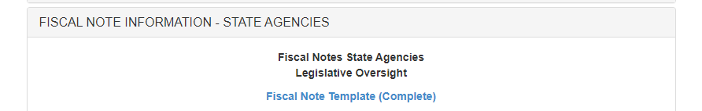
Figure 1: The Fiscal Note Template download page should have a similar appearance to the above figure, which is a screenshot of the download provided in November 2019.
- Don’t forget where you save your installation file!

Installing the program
- After you have downloaded your installation file, close your internet browser and any open programs.
- Open Windows Explorer

To open Windows Explorer, use my favorite keyboard shortcut: Windows + E
- Browse to your download directory and double-click the OversightDocumentsDownload exe file.
- Click “Unzip” to extract the installation files to the specified C:\ directory location. The C:\fnwork directory will be created for you.
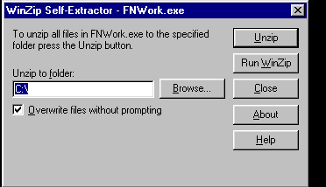
- After the extraction completes, click the “Close” button. You’re now ready to use the worksheet.

Files and forms included in the installation package
The c:\FNWork directory should include the following files.
C: \ FNWork

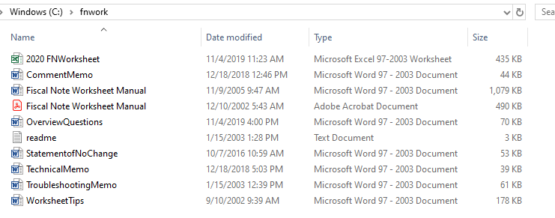
Note that the filenames, sizes, or last-modified dates may vary, but should be similar to this listing.
- It is good practice to routinely open and review the readme.txt file for last-minute instructions and installation tips.

- The most current edition of this manual can be accessed by double-clicking Fiscal Note Worksheet Manual.doc.

The FNWorksheet excel spreadsheet workbook contains the following worksheets:
Visible Worksheets Purpose
"Summary of Fiscal Impact" Summarizes fiscal note worksheets
"General Revenue" General Revenue fund costs by category
"Federal" Federal fund costs by category worksheet
"Local" Local Fiscal Impact worksheet
"Instructions" Notes on filling out forms and worksheets.

Hidden Worksheets (select Format, Sheet, Unhide from the menu)
"Local Sheet" & "Local Instructions" Printable forms and instructions for local entities
"Fund" Used in the creation of additional State Funds
"FedFund" Used in the creation of additional Federal Funds

Word Documents Purpose
“OverviewQuestions.doc” Specific questions and expanded fiscal analysis
"CommentMemo.doc" Agency-recommended changes to bill
"TechnicalMemo.doc" To report typos or inaccurate statute references
"StatementofNoChange.doc" Updated Fiscal Note/no change on fiscal impact
"TroubleshootingMemo.doc" Suggestions for future version of this workbook
"WorksheetTips.doc" Created to answer frequently-asked questions
“Fiscal Note Worksheet Manual.doc” This manual

Program notes
- This workbook uses Visual Basic for Applications "code behind forms."

- To view code or make minor changes, you must “unprotect” the worksheets.
- To unprotect a worksheet, select Tools, Protection, Unprotect sheet… from the Excel menu bar.
- Protecting worksheets allows you to tab between unlocked cells--all cells but data entry cells remain locked.
- The worksheets in this workbook are NOT password protected. Leave the password entry area blank when you re-protect the worksheets. (Tools, Protection, Protect sheet...)

Excel setup
You must enable macros in Excel in order to use these worksheets and documents.

- From Excel's menu, select Tools, Macro, Security. Change the settings to Medium. When project opens, choose the "Enable Macros" option. (see Figure 8.)
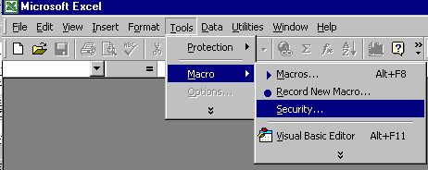
Figure 2: Adjusting macro security settings in Excel.
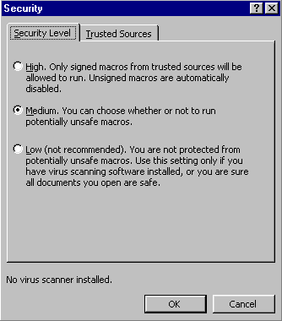
Figure 3: Setting the macro security level to Medium in Excel.

Opening FNWorksheet.xls
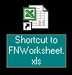
Access the Fiscal Note Worksheet by double-clicking on the c:\FNWork\FNWorksheet.xls filename in Windows Explorer or on the “Shortcut to FNWorksheet.xls” icon on the desktop.
You will have to click the “Enable macros” button every time you open the Fiscal Note Worksheet.
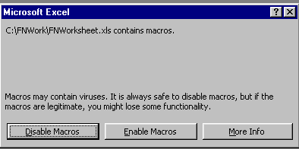
Figure 4: Enabling macros in the Fiscal Note Worksheet.

Chapter
2
Chapter 2
Getting started
A Quick-Start guide to the Fiscal Note Worksheet.

Getting Help
There is more than one way to get help in the Fiscal Note Worksheet. Support resources include those outlined in the bulleted list below as well as context-specific comments provided directly on user forms and worksheets, tool-tips that pop-up when you tab through the worksheets or hover your mouse over various options, and information provided by pressing the F1 key or viewing the status bar at the bottom of the Word forms.

Additional resources may be provided directly to you in the form of FAQs (Frequently-Asked Questions documents) on the website or distributed via e-mail.

List of Support Resources
- This manual, located at C:\FNWork\Fiscal Note Worksheet Manual.doc and accessible from the “Main Menu” tab of the user form. Select “View Fiscal Note Worksheet Manual” option and click the “OK” button. (see Figure 9)
- The summary of instructions located on the user form’s “Instructions” tab. (see Figures 10 & 12)
- The step-by-step worksheet instructions located on the “Instructions” Excel worksheet, accessible via the “Instructions” hyperlinks sprinkled throughout the worksheets or from the “Get More Detailed Instructions” button on the user form’s (summary of) “Instructions” tab. (see Figures 12, 13, 14)
- The Worksheet Tips and Tricks document, located at C:\FNWork\WorksheeetTips.doc and accessible from the “Main Menu” tab of the user form. Select “View Fiscal Note Worksheet Manual” option and click the “OK” button. (see Figure 9)
- Use the “Create a Worksheet Troubleshooting Memo” option on the user form’s “Main Menu” to request technical support, ask questions, report bugs, and suggest program enhancement. (see Figure 9) E-mail the forms to the same place you send your responses: fnote@mail.state.mo.us. A response will be sent as soon as possible.
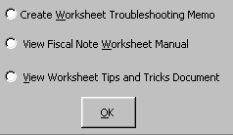

Figure 5: Support resources available from the "Main Menu.."

Menu Navigation
This version of the Fiscal Note Worksheet features a user form designed to assist you in the completion of your fiscal note responses. The user form consists of five forms, each of which can be accessed by clicking a tab at the top of the form.
Figure 6: User form navigation via tabs.
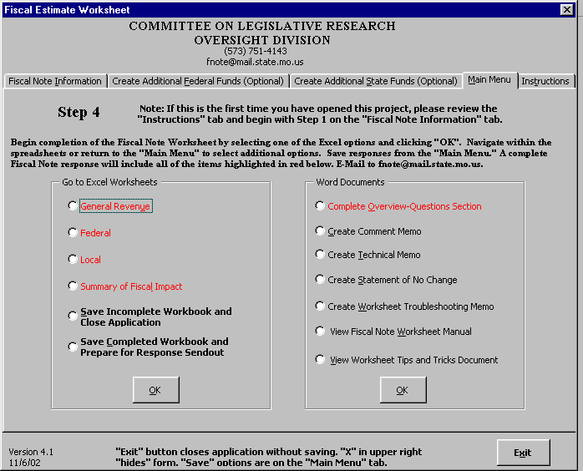
Note that the user form defaults to Step 4 in the fiscal note response preparation process, which corresponds with the “Main Menu” tab of the form. This is to ease navigation as you work with the program. Once you have completed the basic three-step process of setting up your fiscal note response, you will spend most of your time using the “Main Menu” form.
The first time you begin work with the program, you should click the “Instructions” tab to review a brief summary of the form usage and the fiscal note response preparation process. (see Figure 12)

Figure 7: The user form's "Main Menu."
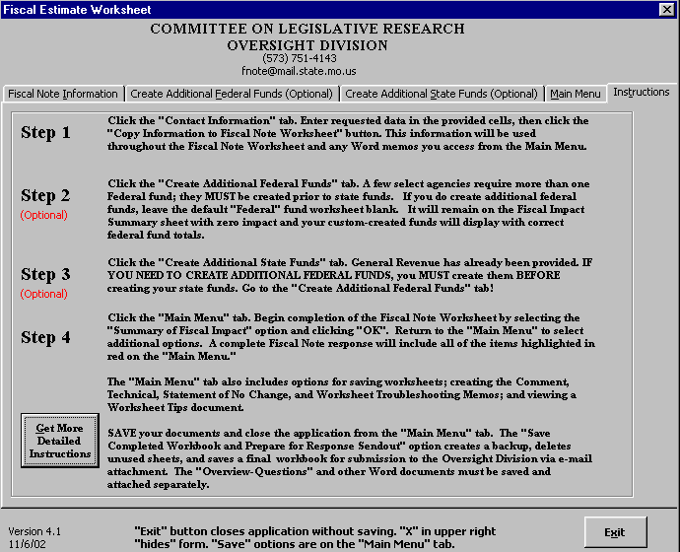

Figure 8: The summary of instructions located on the "Instructions" tab of the user form.
If you click the “Get More Detailed Instructions” button, (see Figure 12 and 13) you will be directed to the “Instructions” sheet in the Excel workbook. (see Figure 14)
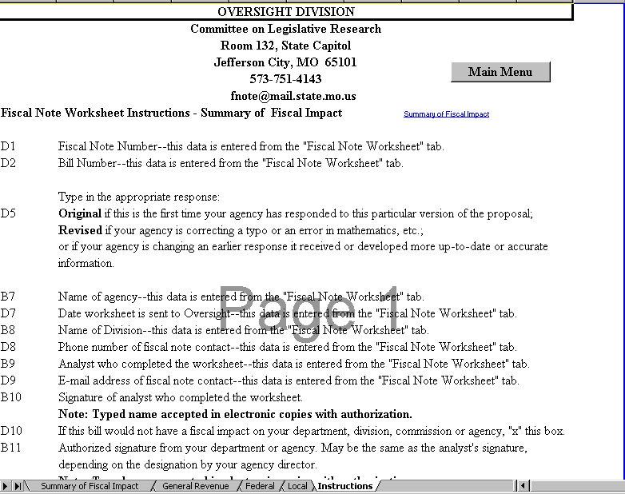
Figure 9: The “Get More Detailed Instructions” button on the user form’s “Instructions” tab.

Figure 10: The "Instructions" sheet in the Excel workbook.

Step 1

The “Fiscal Note Information” form

- Click the “Fiscal Note Information” tab on the user-form.
- Enter the requested data in the cells provided, tabbing between options.
- Click the “Copy Information to Fiscal Note Worksheet” button.
The information you enter on the “Fiscal Note Information” form will be used throughout the Fiscal Note Worksheet and any Word memos you access from the user form’s “Main Menu.”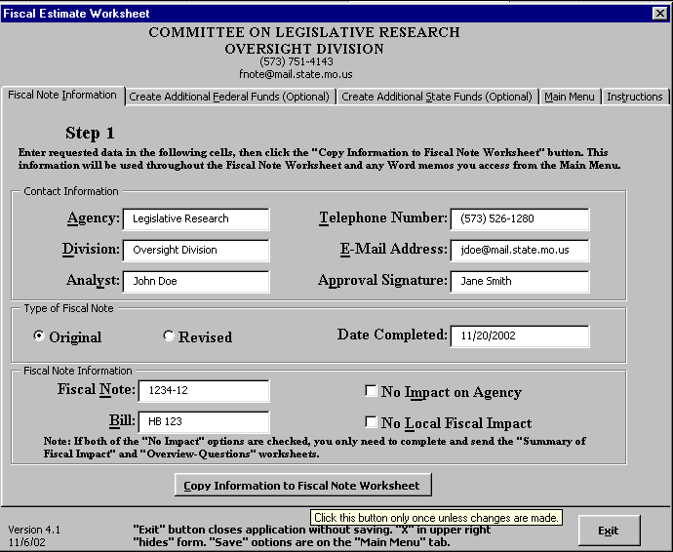
Figure 11: Filling out the "Fiscal Note Information" form.
Note that the “Date Completed:” text box defaults to the current date, which can be changed if necessary. When the worksheet is saved and then later re-opened, the data originally entered from this location will be reloaded into the form for update, if necessary. The “Copy Information to Fiscal Note Worksheet” button should only be clicked if any of this information changes.
If both the “No Impact on Agency” and the “No Local Fiscal Impact” checkboxes are checked, only the “Summary of Fiscal Impact” worksheet and the “Overview-Questions” document need to be completed for a complete response.
Once the “Copy Information to Fiscal Note Worksheet” button has been clicked, contact information is automatically loaded into the “Summary of Fiscal Impact” worksheet (see below.) The “Fiscal Note:” and “Bill:” information is also copied to appropriate locations throughout the other Excel worksheets. You can navigate to the worksheets by clicking the “x” in the upper, right-hand corner of the user form or by selecting the “Main Menu” tab, clicking the “Summary of Fiscal Impact” option button, and clicking the “OK” button. Either option hides the user form and brings the Excel workbook and its worksheets into focus.
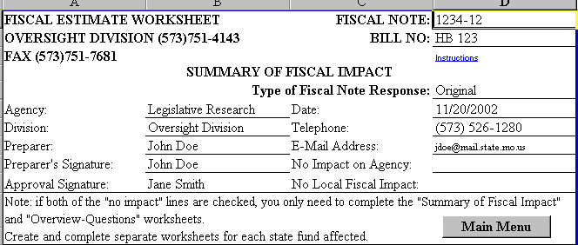
Figure 12: Information copied from the "Fiscal Note Information" form to the "Summary of Fiscal Impact" worksheet.
Note that you can return to the user forms at any time by clicking the “Main Menu” buttons provided on the worksheets.

Step 2

The “Create Additional Federal Funds (Optional)” form

- Click the “Create Additional Federal Funds (Optional)” tab on the user-form. (see Figure 17)
- Click the “Create Federal Fund” button. (see Figure 18)
- When prompted, enter an appropriate name. The name should contain less than 20 characters and should not contain any special characters, like brackets, quotation marks; …
This step is entirely optional depending on your agency’s need to track separate federal funds. If you need to create additional federal funds, however, they MUST be created prior to any additional state funds. This is to ensure that fund information calculates and updates correctly on the “Summary of Fiscal Impact” worksheet. (see Figure 19)
If you do create additional federal funds, leave the default “Federal” fund blank. It will remain on the “Summary of Fiscal Impact” worksheet with zero impact and your custom-created funds will display with correct federal fund totals.
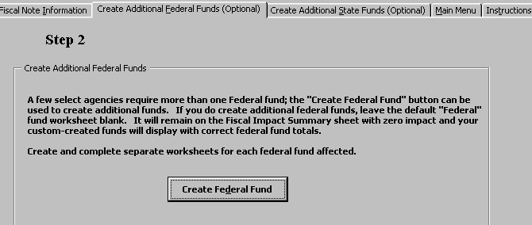
Figure 13: The "Create Additional Federal Funds (Optional)" form.
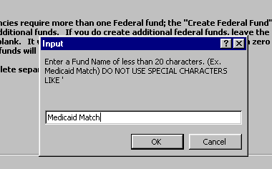
Figure 14: Naming the new federal fund.
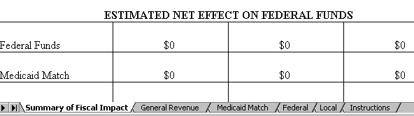
Figure 15: The federal fund "Medicaid Match" on the "Summary of Fiscal Impact" worksheet. Note the “Medicaid Match” fund worksheet tab.
Create as many federal funds as you will need for this fiscal note response before moving on to the next step.

Step 3

The “Create Additional State Funds (Optional)” form

- Click the “Create Additional State Funds (Optional)” tab on the user-form. (see Figure 20)
- Click the “Create State Fund” button. (see Figure 21)
- When prompted, enter an appropriate name. The name should contain less than 20 characters and should not contain any special characters, like brackets, quotation marks; …
This step is entirely optional depending on your agency’s need to track separate state funds. If you need to create additional federal funds, however, they MUST be created prior to any additional state funds. This is to ensure that fund information calculates and updates correctly on the “Summary of Fiscal Impact” worksheet. (see Figure 22)
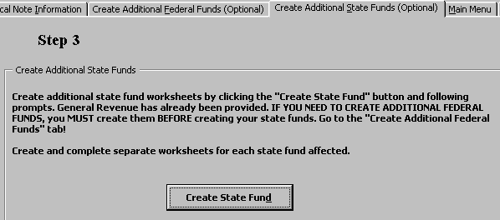
Figure 16: The "Create Additional State Funds (Optional)" form.
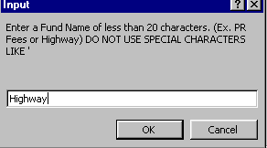
Figure 17: Adding a new state fund named "Highway".

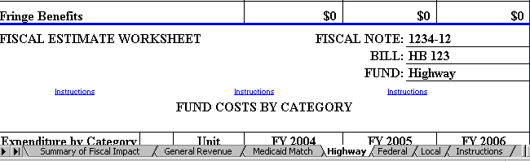
Figure 18: The newly-created "Highway" state fund worksheet.
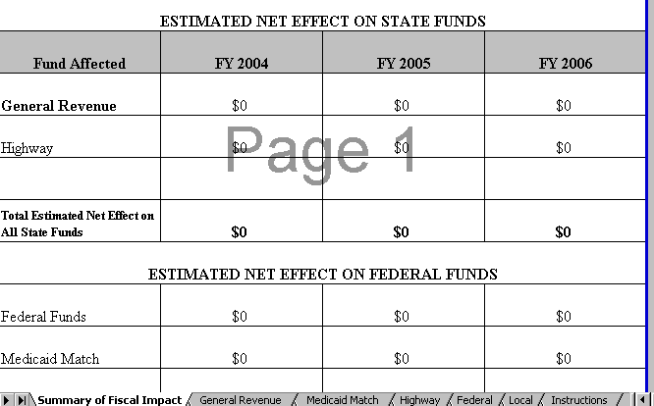
Figure 19: The newly-created "Highway" state fund on the "Summary of Fiscal Impact" worksheet.
Create as many state funds as you will need for this fiscal note response before moving on to the next step.

Step 4

The “Main Menu” form

- Click the “Main Menu” tab on the user-form. (see Figure 24)
- Choose the appropriate option and click the “OK” button.

Figure 20: The "Main Menu" form.
Note that a complete fiscal note response will include all of the items highlighted in red on the “Main Menu” form.
Working with the various worksheet and document options available from the “Main Menu” will be covered in more detail in the next chapter, “Completing a Fiscal Note Response.”

Save Options on the Main Menu
- The “Save Incomplete Workbook and Close Application” option prompts for a filename and saves your incomplete workbook in the C:\FNWork directory.

- The “Save Completed Workbook and Prepare for Response Sendout” option prompts for a filename, saves a backup copy of the file with the prefix “bk”, deletes unused worksheets, and saves a final workbook without the unused worksheets for submission to the Oversight Division.
- The “Overview-Questions” document and other Word memos must be saved and attached separately. Completed responses should be e-mailed to fnote@mail.state.mo.us.
Chapter
3
Chapter 3
Completing a fiscal note response
The Fiscal Note Worksheet from start to finish.

Completing Fund Costs by Category Worksheets
Note that these cell-by-cell instructions apply to the Federal and General Revenue fund costs by category worksheets as well as any additional federal or state fund worksheets you have created.

Fund Costs by Category –the Personnel page
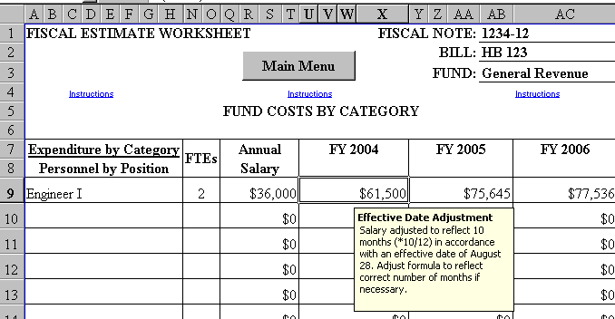
Figure 21: The top of the Personnel page of the General Revenue Fund Costs by Category worksheet.
Note the pop-up help that appears as you tab from cell-to-cell.
The Personnel fund costs by category page must be completed for each fund type. General Revenue, Federal, and Local funds have been created for you. Additional funds should be created from the appropriate tabs on the user form’s “Main Menu.”
Cell Contents (Note: Refer to Figure 25 on the previous page)
AB1 Fiscal Note number –appears on the request sent to your agency from the Oversight Division.
AB2 Bill number in format HB or SB xxx –if the legislation is not a draft, will appear on the request sent to your agency from the Oversight Division
AB3 Fund Type (i.e., General Revenue, Highway, Federal, Other, etc.)
A9 Enter Job Titles, separating by each program or component of the bill.
N9 Enter number of Full Time Equivalents (FTE's) needed.
Q9 Enter current annual salary for the Job Title. Use amount which realistically reflects planned expenditures (i.e., entry-level salary range). Use inflation factor to calculate projected salaries. If the number of FTEs for a Job Title will vary from year-to-year, enter the Job Title as many times as necessary to specify costs for the Job Title for each fiscal year. For example:
Position FTEs Salary FY 2004 FY 2005 FY 2006
Clerk/Typist I 4 $12,660 $52,896
Clerk/Typist II 2 $13,284 $29,016
Programmer 1 $32,998 $34,488
Engineer 2 $36,000 $61,500 $75,645 $77,536
When calculating salaries an inflationary factor of 2.5% should be applied to all three fiscal years indicated. (If the proposed legislation contains an emergency clause which would make it effective during the current fiscal year, the inflationary factor would not be applied to the current fiscal year.) When calculating equipment and expense an inflationary factor of 3% should be applied only to the second and third fiscal years indicated. OA guidelines for equipment and expense costs should be used for the first fiscal year. Please check OA - Budget and Planning's instructions for completing budget requests for inflation factors for some specific items.
U9 Enter cost for each Job Title for the first fiscal year indicated. (NOTE: Unless the proposal has an effective date which dictates otherwise, this column will represent ten months of a fiscal year. Prorate the amount accordingly.)
Y9 Enter cost for each Job Title for the second fiscal year indicated.
AC9 Enter cost for each Job Title for the third fiscal year indicated.
For the following cells, refer to Figure 26 below.
U33 Row Total salaries for fiscal years indicated.
U34 Row The product of Salaries times the Fringe Benefit percentage (40.47%) for the fiscal years indicated.
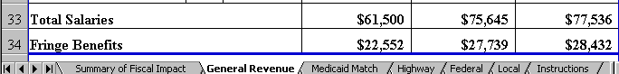
Figure 22: The bottom of the Personnel page of the General Revenue fund costs by category worksheet.

Fund Costs by Category –the Equipment and Expense page
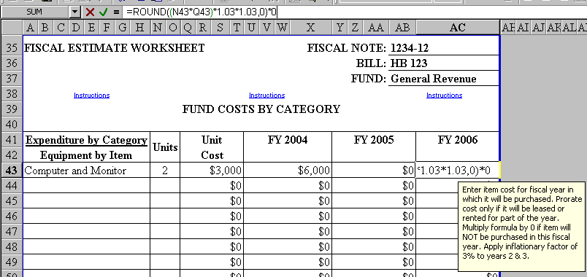
Figure 23: The top of the Equipment and Expense page of the General Revenue fund cost by category worksheet. Note the formula bar, where the formula is being multiplied by zero to reflect the fact that equipment for these positions was purchased previously.
Cell Contents
A43 Enter description of item, separating items by each program or component of the bill.
N43 Enter number of item needed.
Q43 Enter unit cost for each item listed.
U43 Enter cost of item only for fiscal year in which item is to be purchased. Do not prorate cost of item unless item will be leased or rented for just part of a fiscal year.
Multiply the formula by 0 if the item will not be purchased in this fiscal year. Apply the inflationary factor of 3% to years 2 and 3.

For the following cells, refer to Figure 28 below
A57 Row Total equipment cost for fiscal year in which item is to be purchased.
A59 Enter type of expense (e.g., training, telephone, copy machine, office supplies, etc.) for fiscal year in which expense is to be incurred.
N59 Enter number of item needed.
Q59 Enter unit cost for each item listed.
U59 Row Expenses for fiscal years indicated.
A73 Row Total expense for second fiscal year indicated.
A74 Row Total equipment and expense for fiscal years indicated.
U75 Enter local assistance the state would pay for first fiscal year indicated.
Y75 Enter local assistance the state would pay for second fiscal year indicated.
AC75 Enter local assistance the state would pay for third fiscal year indicated.
A76 Specify type of "Other Cost".
U76 Enter "Other Costs" for first fiscal year indicated.
Y76 Enter "Other Costs" for second fiscal year indicated.
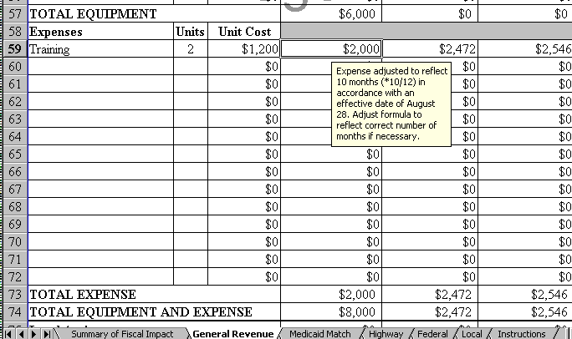
AC76 Enter "Other Costs" for third fiscal year indicated.

Figure 24: The bottom of the Equipment and Expense page of the General Revenue fund cost by category worksheet.

Fund Costs by Category –the Summary of Fund Costs page
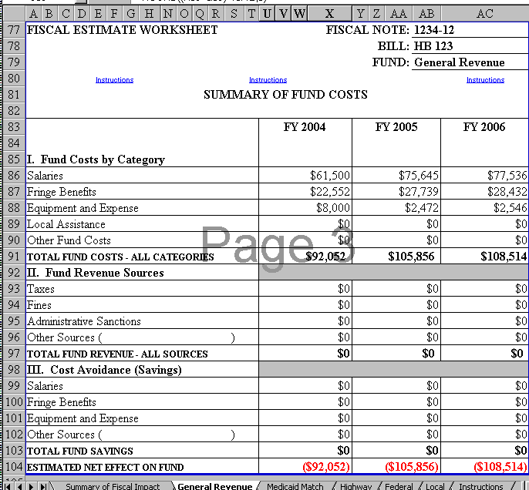
Figure 25: The Summary of Fund Costs page of the General Revenue fund costs by category worksheet.
Cell Content
A86 Row "Salaries" from Fund Costs by Category - Personnel page.
A87 Row "Fringe Benefits" from Fund Costs by Category - Personnel page.
A88 Row "Total Equipment and Expense" from Fund Costs by Category - Expense and Equipment page.
A89 Row "Local Assistance" from Fund Costs by Category - Equipment and Expense page.
A90 Row "Other Costs" from Fund Costs by Category - Equipment and Expense page.
For the following cells, refer to Figure 29 on the previous page.
A91 Row Amount of "Total Fund Costs – All Categories for corresponding fiscal years.
A93 Row Enter Revenue received from Tax for fiscal years indicated.
A94 Row Enter Revenue received from Fines for fiscal years indicated.
A95 Row Enter Revenue received from Administrative Sanctions for fiscal years indicated.
A96 Row Enter Revenue received from Other Sources for fiscal years indicated.
A97 Row Total Fund Revenues received from All Sources for fiscal years indicated.
When calculating any Cost Avoidance or Savings related to salaries, fringe benefits, and expense and equipment remember to use the inflationary factor to project subsequent years.
A99 Row Enter any Cost Avoidance or Savings related to salaries for the fiscal years indicated.
A100 Row Enter any Cost Avoidance or Savings related to Fringe Benefits for the fiscal years indicated.
A101 Row Enter any Cost Avoidance or Savings related to Equipment & Expense for the fiscal years indicated.
A102 Row Enter any Cost Avoidance or Savings related to Other Sources for the fiscal years indicated.
A103 Row Total Fund Savings for the fiscal years indicated.
A104 Row Estimated Net Effect on Fund for fiscal years indicated.

Completing the Overview-Questions document

- Click the “Fiscal Note Information” tab on the user-form. (see Figure 15.)
- Enter the requested data in the cells provided, tabbing between options.
- Click the “Copy Information to Fiscal Note Worksheet” button.
- Click the “Main Menu” tab of the user form.
- Select the “Complete Overview-Questions Section” option and click the “OK” button.
The information you enter on the “Fiscal Note Information” form will automatically update the Overview-Questions document. (see Figure 30 on the next page.)
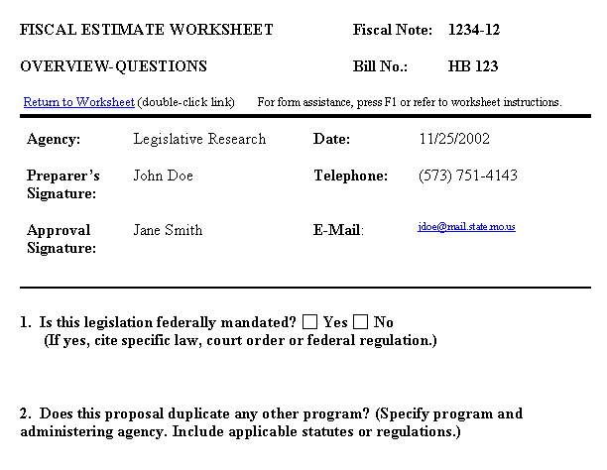
Figure 26: The top portion of the "Overview-Questions" document.
Complete the Overview-Questions document, tabbing between questions. Use as much space as you need. When you complete the form, save it with a new name, preferably one that includes a reference to the fiscal note number. Remember to attach the document to your e-mail response, along with your fiscal note worksheet document and any other Word memos you have completed. Send your e-mail response to fnote@mail.state.mo.us.

Additional information about each of the Overview-Questions

1. Check or "X" appropriate response. If "yes", please cite law, court decision, regulation, or other supporting data. (Oversight Division is required by state law, 23.140, RSMo, to address this question on every fiscal note).
2. If the attached proposal duplicates any other program, please indicate which program(s). Please attach additional sheets, if necessary. (This question is required under section 23.140, RSMo.)
3. If the proposal would affect other State agencies or political subdivision, please indicate. Attach additional sheets, if necessary. (The part of the question relating to political subdivisions is mandated by 23.140, RSMo.)
4. If the proposal would require additional capital improvements or rental space, please specify. Attach additional sheets if necessary. (This question is mandated by section 23.140, RSMo.)
5. Sometimes, especially when a bill is part of a state agency's legislative package, the personnel and equipment needed for a bill are already in the agency budget request before the bill is introduced. If this is true (check with your agency budget office,) please so indicate here.
6. If the proposal would have an economic impact on small businesses, please specify. Small business is defined as a corporation, partnership, sole proprietorship or other business entity that is independently owned or operated and employs fifty or fewer full-time employees. (This question is mandated by section 23.140.)
7. If the legislation directly affects Total State Revenue, please explain how.
8. Please describe the most important parts of this legislation from the point of view of your agency.
9. Enter any potentially significant fiscal effects this proposed legislation might have on revenues or expenditures in fiscal years subsequent to the first three fiscal years the proposal would be in effect Give numerical estimates wherever possible. Please use attachments as needed.
10. If this is a revised Fiscal Estimate Worksheet, please explain reasons for revision.
11. Please explain how the state fiscal impact of the attached proposal was reached. If the request for new full time equivalents (FTEs) is based on workload measures, please list the workload measures. Describe the duties and responsibilities of any new employees which would be requested.

Completing the Local Fiscal Estimate Worksheet
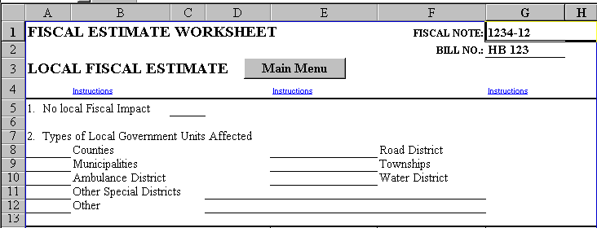
Figure 27: The top of the Local Fiscal Estimate Worksheet.
Cell Content
C5 Check box if this legislation will have no local fiscal impact.
A8 Check appropriate box(es). If you check one of the "Other" boxes, please be specific.

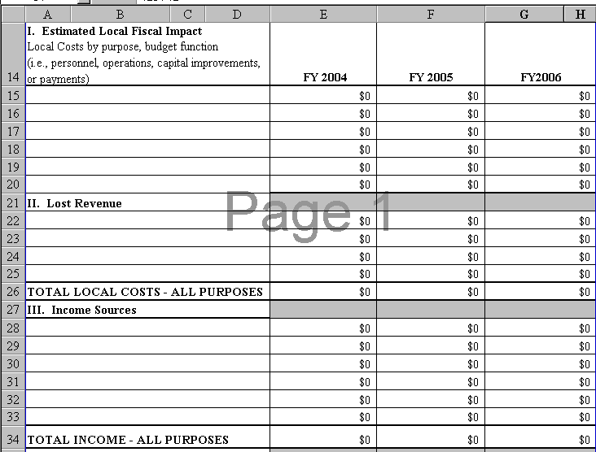
Figure 28: The middle portion of the Local Fiscal Estimate worksheet.
A15 Enter type of local effect(s).
E15 Enter local cost for first fiscal year indicated.
F15 Enter local cost for second fiscal year indicated.
G15 Enter local cost for third fiscal year indicated.
A22 Enter type of Lost Revenue (ex. Doing away with local sales tax.)
E22 Enter lost revenue for first fiscal year.
F22 Enter lost revenue for second fiscal year.
G22 Enter lost revenue for third fiscal year.
E26 Total Local Costs - All Purposes for the first fiscal year indicated.
F26 Total Local Costs - All Purposes for the second fiscal year indicated.
G26 Total Local Costs - All Purposes for the third fiscal year indicated.
A28 Enter type of income source(s).
E28 Enter income source amount for first fiscal year indicated.
F28 Enter income source amount for second fiscal year indicated.
G28 Enter income source amount for third fiscal year indicated.
E34 Total Income - All Sources for the first fiscal year indicated.
F34 Total Income - All Sources for the second fiscal year indicated.
G34 Total Income - All Sources for the third fiscal year indicated.
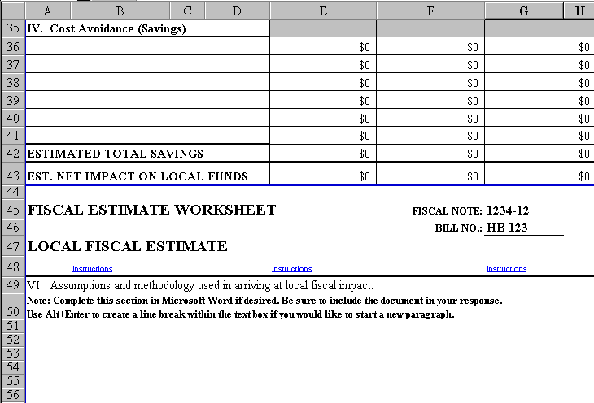
Figure 29: The bottom portion of the Local Fiscal Estimate worksheet.
A36 Enter type of Cost Avoidance or Savings.
E36 Enter amount of Cost Avoidance or Savings for the first fiscal year indicated.
F36 Enter amount of Cost Avoidance or Savings for the second fiscal year indicated.
G36 Enter amount of Cost Avoidance or Savings for the third fiscal year indicated.
E42 Estimated Total Savings for first fiscal year indicated.
F42 Estimated Total Savings for second fiscal year indicated.
G42 Estimated Total Savings for third fiscal year indicated.
E43 Estimated Net Effect On Local Funds for the first fiscal year indicated.
F43 Estimated Net Effect On Local Funds for the second fiscal year indicated.
G43 Estimated Net Effect On Local Funds for the third fiscal year indicated.
A50 Describe the assumptions and methodology used to reach the local fiscal impacts shown. You can complete this section in MS Word if desired.

Completing the Summary of Fiscal Impact Worksheet
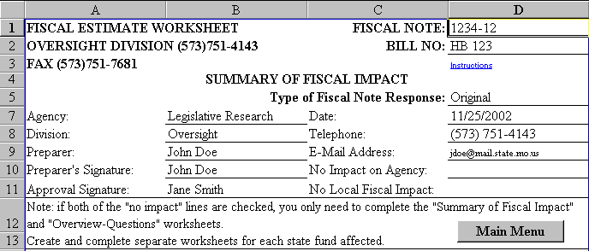
Note that the Summary of Fiscal Impact worksheet will automatically fill with data as the other worksheets are completed. The top portion of the worksheet is updated with information from the “Fiscal Note Information” form, while the interior fund totals are updated from links to the various fund costs by category worksheets.
Figure 30: The top portion of the Summary of Fiscal Impact worksheet.
Cell Content
D1 Fiscal Note Number –entered from “Fiscal Note Information” form. This information appears on the request you received from the Oversight Division.
D2 Bill Number –entered from “Fiscal Note Information” form. This information appears on the request you received from the Oversight Division unless the legislation does not yet have a bill number.
D5 Original if this is the first time your agency has responded to this particular version of the proposal; Revised if your agency is correcting a typo or error in mathematics, changing an earlier response it received, or reporting more up-to-date or accurate information.
B7 Name of agency–entered from “Fiscal Note Information” form.
D7 Date worksheet is sent to Oversight–entered from “Fiscal Note Information” form.
B8 Name of Division–entered from “Fiscal Note Information” form.
D8 Phone number of fiscal note contact–entered from “Fiscal Note Information” form.
B9 Analyst who completed the worksheet–entered from “Fiscal Note Information” form.
D9 E-mail address of fiscal note contact–entered from “Fiscal Note Information” form.
B10 Signature of analyst who completed the worksheet. Note: Typed name accepted in electronic copies with authorization–entered from “Fiscal Note Information” form.
D10 If this bill would not have a fiscal impact on your department, division, commission or agency, "x" this box.
B11 Authorized signature. May be the same as the analyst's signature, depending on the designation by your director–entered from “Fiscal Note Information” form.
D11 If, so far as your agency can determine, the proposal would not have a fiscal impact on any local government or political subdivision, check or "x" this box.
If you can check D10 and D11, you only need to complete Summary of Fiscal Impact worksheet and the Overview-Questions.doc.
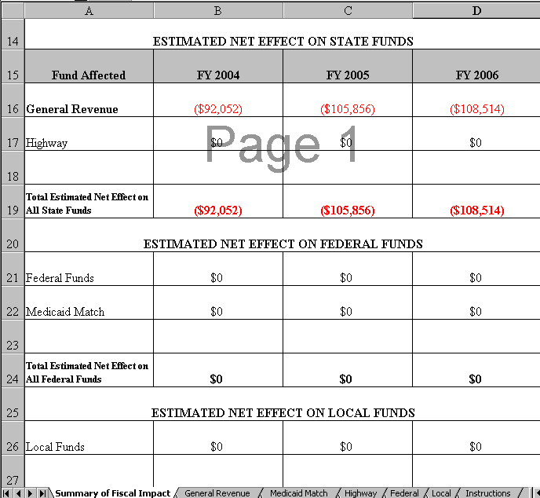
Figure 31: The fund totals portion of the Summary of Fiscal Impact worksheet.
In Figure 35 above, notice that the total from the General Revenue fund cost by category worksheet has been automatically inserted into the summary. The table section calculates Estimated Net Effect on General Revenue, Highway, Federal, and any other funds from information entered in the various fund worksheets. In this particular example, the Highway, Federal Funds, Medicaid Match, and Local Funds rows would automatically fill in and total as their respective worksheets were completed. A properly completed Summary of Fiscal Impact should require no direct typing.

Submitting your Response

- When you have completed your worksheets and Overview-Questions documents, click the “Main Menu” tab on the user-form. (see Figure 24)
- Select “Save Completed Workbook and Prepare for Response Sendout” and click the “OK” button. You will be prompted for a filename.
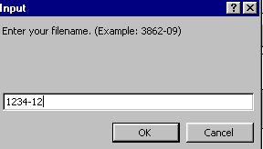
In Figure 36, the filename 1234-12 has been entered. Figure 37 shows the message box that will appear after the backup file, bk1234-12.xls, and your response file, 1234-12.xls, have been saved. The backup file should be used if you need to revise your response in the future. The response file has been purged of extraneous worksheets and instructions to create a smaller file for sending through the internet as an e-mail attachment.
Figure 32: Entering your filename.
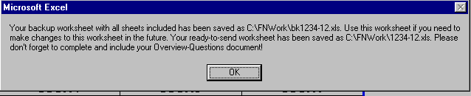
Figure 33: The message that displays after your backup file and response files have been saved.
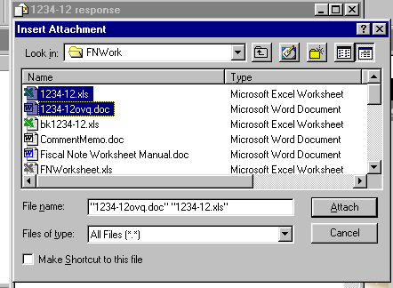
After you have saved your response, open your E-mail program. Create a new message addressed to fnote@mail.state.mo.us and add your attachments before sending the e-mail. Unless you have copied them elsewhere or your IT staff has modified this program, your response files should be located in C:\FNWork. Remember to include the Overview-Questions.doc you have saved with a new name (in this example: 1234-12ovq.doc). In Figure 38, the Excel worksheet 1234-12.xls and the Overview-Questions document 1234-12ovq.doc are highlighted for attachment to an e-mail message created with Outlook Express.

Figure 34: Attaching the worksheet and overview-questions document to the e-mail response.
It is a good idea to backup your files to a shared location or user directory on the network!
Chapter 4
Chapter
4
Working with the other word documents
Step-by-step directions to the Statement of No Change and the Comment, Technical, and Troubleshooting Memos.

The Statement of No Change
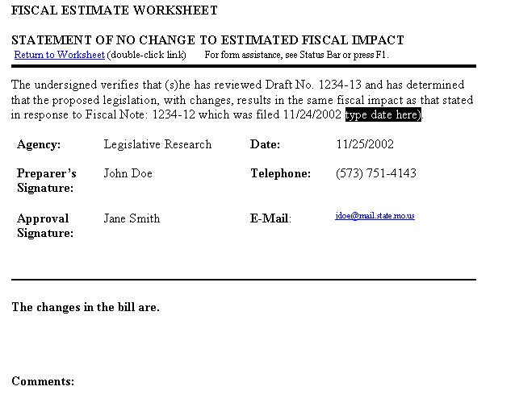
Figure 35: Entering the date filed in the Statement of No Change document.

- Click the “Fiscal Note Information” tab on the user-form. (see Figure 15.)
- Enter the requested data in the cells provided, tabbing between options.
- Click the “Copy Information to Fiscal Note Worksheet” button.
- Click the “Main Menu” tab of the user form.
- Select the “Create Statement of No Change” option and click the “OK” button.
The information you enter on the “Fiscal Note Information” form will automatically update the Statement of No Change. Enter the additional requested information, tabbing between fields.
Field Contents
Draft No.: Fiscal Note Number for this fiscal note response—copied from the "Fiscal Note Information" form.
Fiscal Note: Enter Fiscal Note Number of previous fiscal note response.
(type date here): Enter date previous fiscal note response was sent to Oversight Division.
Agency: Agency name --copied from the "Fiscal Note Information" form.
Date: Date this form is sent to Oversight –copied from the "Fiscal Note Information" form.
Preparer’s Signature Analyst who completed this form –copied from the "Fiscal Note Information" form.
Telephone: Telephone number of analyst who completed form –copied from the "Fiscal Note Information" form.
Approval Signature: Typed signature accepted on electronic forms with authorization –copied from the "Fiscal Note Information" form.
E-Mail: E-Mail address of analyst who completed form –copied from the "Fiscal Note Information" form.
The changes in the bill are:
Identify differences between the current version of the proposed legislation and previous proposed legislation.
Comments: Enter any additional comments.
Note that the Return to Worksheet link returns to C:\FNWorksheet.xls. Use your Windows task bar to return to your worksheet if you are working on a workbook with a different name!

The Comment Memo
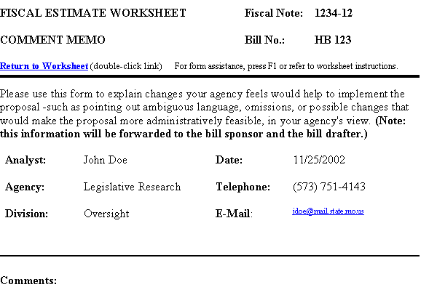
Figure 36: The Comment memo.


- Click the “Fiscal Note Information” tab on the user-form. (see Figure 15.)
- Enter the requested data in the cells provided, tabbing between options.
- Click the “Copy Information to Fiscal Note Worksheet” button.
- Click the “Main Menu” tab of the user form.
- Select the “Create Comment Memo” option and click the “OK” button.
The information you enter on the “Fiscal Note Information” form will automatically update the Comment Memo. Enter the additional requested information, tabbing between fields.
Use the comment memo to explain changes your agency feels would help to implement the proposal –such as pointing out ambiguous language, omissions, or possible changes that would make the proposal more administratively feasible, in your agency’s view. The Comment memo is forwarded to the bill sponsor and the bill drafter.

Field Contents
Fiscal Note: Fiscal Note Number for this fiscal note response—copied from the "Fiscal Note Information" form.
Bill No.: Fiscal Note Number for this fiscal note response—copied from the "Fiscal Note Information" form.
Analyst: Analyst who completed this form –copied from the "Fiscal Note Information" form.
Date: Date this form is sent to Oversight –copied from the "Fiscal Note Information" form.
Agency: Agency name --copied from the "Fiscal Note Information" form.
Telephone: Telephone number of analyst who completed form –copied from the "Fiscal Note Information" form.
Division: Division name --copied from the "Fiscal Note Information" form.
E-Mail: E-Mail address of analyst who completed form –copied from the "Fiscal Note Information" form.
Comments: Enter your comments in this section.
Note that the Return to Worksheet link returns to C:\FNWorksheet.xls. Use your Windows task bar to return to your worksheet if you are working on a workbook with a different name!

The Technical Memo

- Click the “Fiscal Note Information” tab on the user-form. (see Figure 15.)
- Enter the requested data in the cells provided, tabbing between options.
- Click the “Copy Information to Fiscal Note Worksheet” button.
- Click the “Main Menu” tab of the user form.
- Select the “Create Technical Memo” option and click the “OK” button.
The information you enter on the “Fiscal Note Information” form will automatically update the Technical Memo. Enter the additional requested information, tabbing between fields.
Use the technical memo to point out errors in the draft bill. Technical errors include but are not limited to typos, inaccurate or inappropriate section references, and omitted words, lines, and subsections. Please use the Comment Memo to communicate comments, suggestions for additional provisions or deletions of existing provisions, etc. The Technical memo is forwarded to the bill drafter.
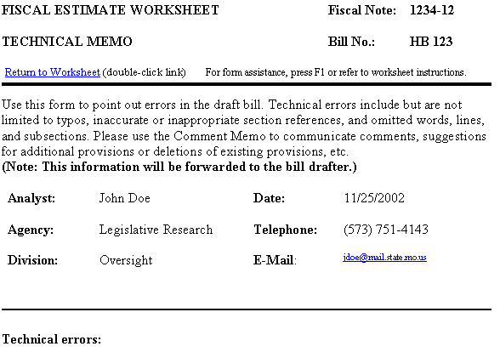
Figure 37: The Technical Memo.
Field Contents
Fiscal Note: Fiscal Note Number for this fiscal note response—copied from the "Fiscal Note Information" form.
Bill No.: Fiscal Note Number for this fiscal note response—copied from the "Fiscal Note Information" form.
Analyst: Analyst who completed this form –copied from the "Fiscal Note Information" form.
Date: Date this form is sent to Oversight –copied from the "Fiscal Note Information" form.
Agency: Agency name --copied from the "Fiscal Note Information" form.
Telephone: Telephone number of analyst who completed form –copied from the "Fiscal Note Information" form.
Division: Division name --copied from the "Fiscal Note Information" form.
E-Mail: E-Mail address of analyst who completed form –copied from the "Fiscal Note Information" form.
Technical errors: Enter any technical problems (such as drafting errors, incorrect statute references, etc.) with the proposal as written.
Note that the Return to Worksheet link returns to C:\FNWorksheet.xls. Use your Windows task bar to return to your worksheet if you are working on a workbook with a different name!
You do not have to wait until you are ready to send a completed fiscal note response to the Oversight Division to send a Technical Memo. If your agency feels a problem is important, please send the Technical Memo to Oversight Division at fnote@mail.state.mo.us immediately.

The Worksheet Troubleshooting Memo
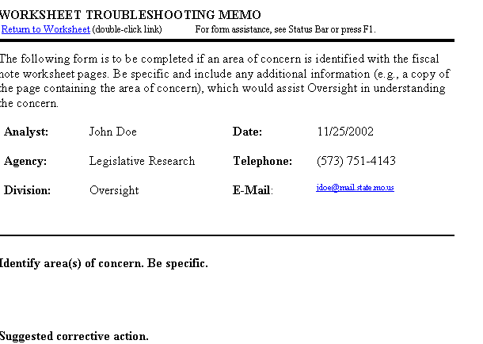
Figure 38: The Worksheet Troubleshooting Memo.

- Click the “Fiscal Note Information” tab on the user-form. (see Figure 15.)
- Enter the requested data in the cells provided, tabbing between options.
- Click the “Copy Information to Fiscal Note Worksheet” button.
- Click the “Main Menu” tab of the user form.
- Select the “Create Worksheet Troubleshooting Memo” option and click the “OK” button.
The information you enter on the “Fiscal Note Information” form will automatically update the Worksheet Troubleshooting Memo. Enter the additional requested information, tabbing between fields.
Use the Worksheet Troubleshooting Memo to report problems, request technical assistance, or suggest enhancements to the Fiscal Estimate Worksheet program. Your memo will be forwarded to technical support staff.
Field Contents
Analyst: Analyst who completed this form –copied from the "Fiscal Note Information" form.
Date: Date this form is sent to Oversight –copied from the "Fiscal Note Information" form.
Agency: Agency name --copied from the "Fiscal Note Information" form.
Telephone: Telephone number of analyst who completed form –copied from the "Fiscal Note Information" form.
Division: Division name --copied from the "Fiscal Note Information" form.
E-Mail: E-Mail address of analyst who completed form –copied from the "Fiscal Note Information" form.
Identify area(s) of concern. Be specific:
Enter any technical problems you are experiencing with the Excel worksheets or Word documents.
Suggested corrective action:
Enter your enhancement or bug-fix suggestions here.
Note that the Return to Worksheet link returns to C:\FNWorksheet.xls. Use your Windows task bar to return to your worksheet if you are working on a workbook with a different name!

